# SQL Assignment

## Link to Practice

[**https://www.sql-practice.com/**](https://www.sql-practice.com/)

## DB To Select

**Northwind.db**

## Schema

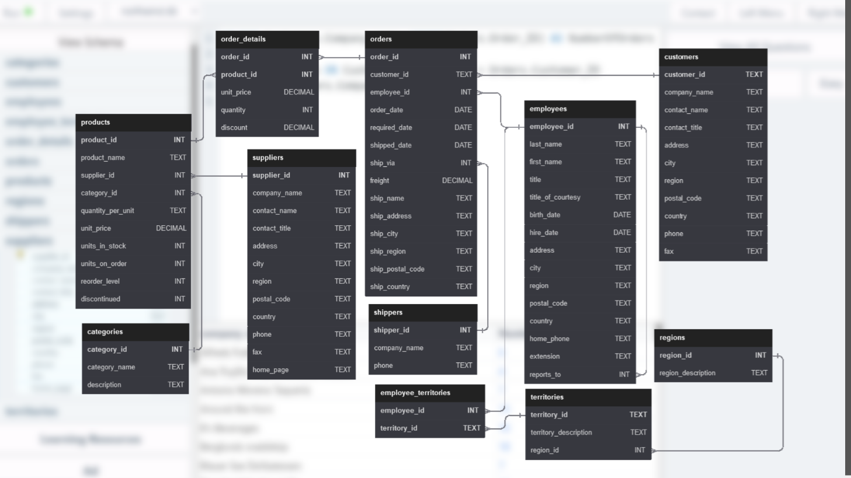

## Questions

1. Get the total number of orders placed by each customer

🡪 SELECT customer_id, count(order_id) AS no_of_orders FROM orders GROUP BY customer_id;

1. Find all suppliers who provide products in the ‘Seafood’ category

🡪 SELECT s.supplier_id FROM products p

JOIN categories c ON p.category_id =c.category_id

JOIN suppliers s ON p.supplier_id = s.supplier_id

WHERE category_name = 'Seafood';

1. Get the total quantity of each product sold

🡪 SELECT product_id , SUM(quantity) FROM order_details GROUP By product_id;

1. Find the total sales (Quantity*Unit_Price) for each category of products

🡪 SELECT category_id, SUM(quantity_per_unit * unit_price) AS total_sales

FROM products GROUP BY category_id;

1. List the employees and the number of orders each employee has taken

🡪 SELECT employee_id , COUNT(order_id) AS no_of_orders

FROM orders GROUP BY employee_id;

1. Get the customers who have placed more than 10 orders

🡪 SELECT customer_id , COUNT(order_id) AS total_order FROM orders

GROUP BY customer_id HAVING total_order>10 ;

1. Get the top 5 most sold products

🡪 SELECT product_id, sum(quantity ) FROM order_details GROUP BY product_id ORDER BY quantity DESC LIMIT 5 ;

1. Find the products that have never been ordered

🡪 SELECT p.product_id

FROM products p

LEFT JOIN order_details o ON p.product_id=o.product_id

WHERE order_id is null;

1. Find the customers who have not placed any orders

🡪 SELECT c.customer_id , order_id FROM customers c

LEFT JOIN orders o ON c.customer_id = o.customer_id

WHERE order_id Is null;

1. List all ‘Orders’ with ‘Customer’ details and ‘Employee’ who processed it

🡪 SELECT order_id , c.customer_id, company_name, contact_name, c.address, e.employee_id

FROM orders o

JOIN customers c ON o.customer_id = c.customer_id

JOIN employees e ON o.employee_id = e.employee_id

WHERE e.employee_id IS NOT null;

1. Calculate the average product price by category

🡪 SELECT category_id, AVG(unit_price) as average FROM products GROUP BY category_id;

1. Find the total revenue generated by each employee

🡪 SELECT employee_id, SUM(quantity* unit_price) AS revenue FROM order_details od

JOIN orders o on od.order_id = o.order_id

GROUP BY employee_id;

1. List all orders shipped to ‘Germany’

🡪 SELECT order_id FROM orders WHERE ship_country='Germany';

1. Find the most expensive product in each category

🡪 SELECT category_id , MAX(unit_price) FROM products GROUP BY category_id;

1. Find the total revenue for the year 2016

🡪 SELECT YEAR(order_date) AS year_order, SUM(quantity*unit_price) AS revenue

FROM order_details od

JOIN orders o ON od.order_id = o.order_id

WHERE year_order = 2016;

1. List all products that are discontinued

🡪 SELECT product_id FROM products WHERE discontinued IS NOT '0';

1. List all the distinct countries to which orders have been shipped

🡪 SELECT DISTINCT(ship_country) FROM orders;

1. Find all employees who report to ‘Andrew Fuller’

🡪 SELECT employee_id FROM employees WHERE reports_to = 2;

1. Find the customers who have spent more than $5000 in total

🡪 SELECT customer_id, SUM(unit_price* quantity ) AS sales

FROM order_details od

JOIN orders o ON od.order_id = o.order_id

GROUP BY customer_id HAVING sales> 5000;

1. List the top 5 employees who have processed the most orders

🡪 SELECT employee_id , COUNT(order_id) AS od

FROM orders

GROUP BY employee_id

ORDER BY od DESC LIMIT 5 ;

1. Get the list of customers who have ordered ‘Chai’ product

🡪 SELECT customer_id FROM order_details od

JOIN orders o ON o.order_id = od.order_id

JOIN products p ON od.product_id = p.product_id

WHERE product_name = 'Chai';

1. Get the employees who have processed orders for ‘Chai’ product

🡪 SELECT employee_id

FROM order_details od

JOIN orders o ON o.order_id = od.order_id

JOIN products p ON od.product_id = p.product_id

WHERE product_name = 'Chai';

1. Find the most common shipping country

🡪 SELECT ship_country , COUNT(order_id) AS total_shipping FROM orders

GROUP BY ship_country ORDER BY total_shipping DESC LIMIT 1;

1. Find the order with the highest total cost

🡪 SELECT order_id , SUM((unit_price* quantity) - (unit_price* quantity*discount) )AS total_cost

FROM order_details

JOIN products p on p.product_id=od.product_id

ORDER BY total_cost desc LIMIT 1;

1. Find the employees who have processed more than 100 orders

🡪 SELECT employee_id , COUNT(order_id) AS total_orders FROM orders GROUP BY employee_id HAVING total_orders>100 ;

1. Find the customer who has ordered the most ‘Chai’ product

🡪 SELECT customer_id , COUNT(o.order_id) AS no_orders

FROM order_details od

JOIN orders o ON o.order_id = od.order_id

JOIN products p ON od.product_id = p.product_id

WHERE product_name = 'Chai'

GROUP BY customer_id ORDER BY no_orders DESC LIMIT 1;

1. Find the average quantity of products ordered in each order

🡪 SELECT order_id, SUM(quantity) AS average FROM order_details GROUP BY order_id;

1. Find the top 3 most popular categories of products ordered

🡪 SELECT category_id, COUNT(order_id) AS total_orders FROM products p

JOIN order_details od ON p.product_id=od.product_id

GROUP BY category_id ORDER BY total_orders desc limit 3;

1. Find the month in the year 2016 with the highest total sales

🡪 SELECT MONTH(order_date) AS month_order, SUM(quantity*unit_price) AS sales

FROM order_details od

JOIN orders o ON od.order_id = o.order_id WHERE YEAR(order_date) IS 2016

ORDER BY sales DESC LIMIT 1;

1. Find the employee who processed the most orders in August 2016

🡪 SELECT employee_id , COUNT(order_id) AS total_orders FROM orders

WHERE order_date BETWEEN '2016-08-01' AND '2016-08-31'

GROUP BY employee_id order by total_orders DESC LIMIT 1;

1. Find the top 3 customers who have ordered the most products

🡪 SELECT customer_id , COUNT(order_id) AS total_orders

FROM orders GROUP BY customer_id ORDER BY total_orders DESC LIMIT 3;

1. Find the employees who have not processed any orders

🡪 SELECT e.employee_id, o.order_id FROM employees e

LEFT join orders o ON e.employee_id = o.employee_id

WHERE o.order_id IS NULL;

1. Find the suppliers who supply the top 5 most sold products

🡪 SELECT supplier_id FROM order_details od

JOIN products p ON p.product_id = od.product_id

GROUP BY od.product_id ORDER BY quantity DESC LIMIT 5;

1. Find the customers who have ordered products from all categories

🡪 SELECT customer_id FROM order_details od

JOIN orders o ON o.order_id = od.order_id

JOIN products p ON p.product_id = od.product_id

GROUP BY o.order_id HAVING COUNT (DISTINCT(category_id))>7;

1. Find the total sales for each year

🡪 SELECT YEAR(order_date ) as order_year , SUM(quantity*unit_price) as sales

FROM order_details od JOIN orders o ON od.order_id = o.order_id

GROUP BY YEAR(order_date);

36. classify customers based on their total order amounts such that total order amounts > 5000 should be classified as ‘High Value’, if > 1000 then as ‘Medium Value’ and otherwise as ‘Low Value’

Here is the sample output

🡪SELECT company_name, SUM(unit_price*quantity) as sales,

( CASE WHEN SUM(unit_price*quantity) > 5000 THEN 'High Value'

WHEN SUM(unit_price*quantity) > 1000 THEN 'Medium Value' ELSE 'Low Value' END ) AS CustomerClass

FROM orders o

JOIN order_details od ON od.order_id=o.order_id

JOIN customers c ON c.customer_id= o.customer_id

GROUP BY o.customer_id;

37. classify products based on their sales volume such that TotalQuantity > 1000 Then SalesCategory as ‘High Sales’. If TotalQuantity>500 Then ‘Medium Sales’ and else ‘Lower Sales’

🡪SELECT product_name, SUM(quantity) AS TotalOrderedAmount,

( CASE WHEN SUM(quantity) > 1000 THEN 'High Sales'

WHEN SUM(quantity) > 500 THEN 'Medium Sales'

ELSE 'Low Sales' END )

AS SalesCategory

FROM order_details od

JOIN products p ON p.product_id= od.product_id

GROUP By product_name;

38. classify employees based on the number of orders they have processed such that NumberOfOrders > 100 Then PerformanceCategory as ‘High Performing’. If NumberOfOrders>50 Then ‘Medium Performing’ and else ‘Lower Performing’

Here is the sample output

🡪SELECT first_name, last_name, COUNT(order_id) AS NumberOfOrders ,

( CASE WHEN COUNT(order_id) > 100 THEN 'High Performing'

WHEN COUNT(order_id)> 50 THEN 'Medium Performing'

ELSE 'Low Performing' END )

AS PerformanceCategory

FROM orders o

JOIN employees e ON e.employee_id=o.employee_id

GROUP BY e.employee_id

ORDER BY first_name;